The purpose of Word2Vec **is to group vectors of similar words together in a vector space**. The meaning of that is to capture the context of a word in a document, semantic similarity and relation with other words. The idea behind Word2Vec is that the meaning of a word can be inferred by the surrounding words.

Word2Vec is a **two-layer neural network that processes text.** The input is a text corpus and the output are vectors, typically of several hundred dimensions, for every word in the vocabulary.

If Word2Vec is trained on big enough data sets, like billions of words, Word2Vec can make highly accurate estimation about a word’s meaning based on past appearances. Not only that similar words are grouped together in the same direction.

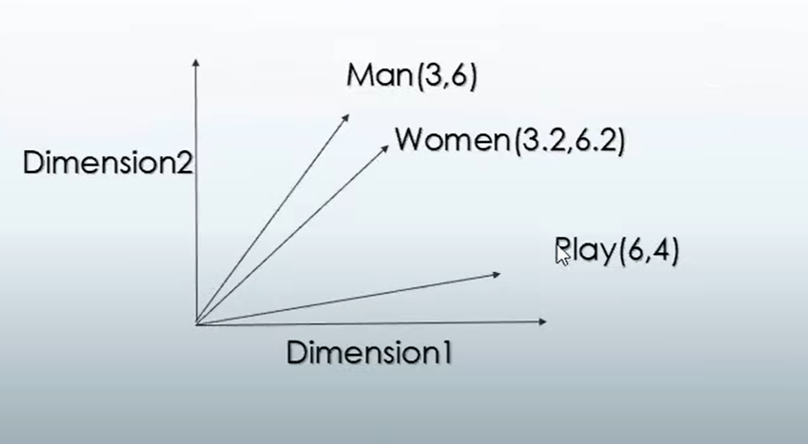

algebraic operation can also be applied, for example that vector("King") - vector("Man") + vector("Woman") gives a vector very close to the vector representation of "Queen"[15].

